Bifurcation diagram, 要放在4個population trajectories 下面的。
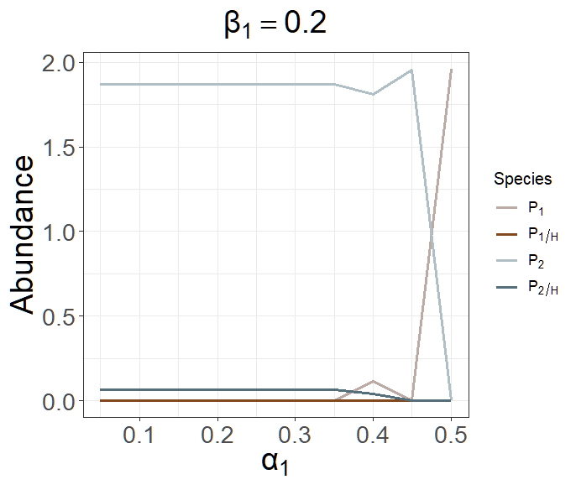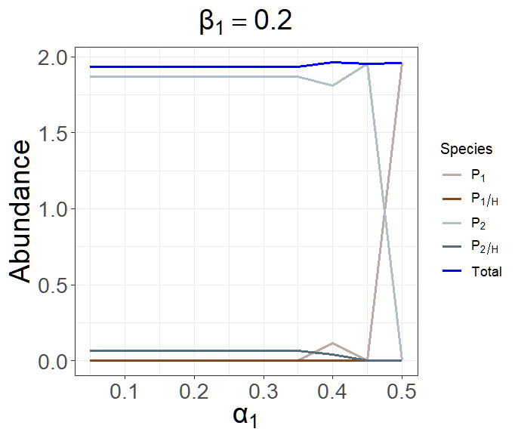
2025/2/12
File name: Pre1Sim3NC2
When α₁ is low (<0.4), P₂ and P_{2/H} can persist. However, an increase in α₁ will interfere with the persistence of H and, accordingly, P_{2/H}. After P_{2/H} dies, P₂ will receive the abundance that is sacrificed by P_{2/H}.

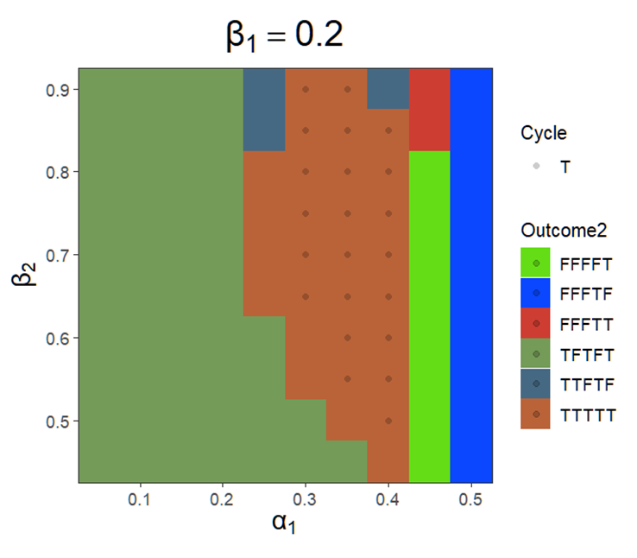
2025/2/12
File name: Pre1Sim3NC fix b1=02
An increase in β₂ will make H easier to persist but make P₂ easier to die.
It is assumed that an increase of β₂ will make the system likely to coexist.
這張圖好像不太有意義，因為理所當然，且增加β₂不會使FFFFT變成TFTFT，推測是S過小，使H仍無法pesist的緣故。

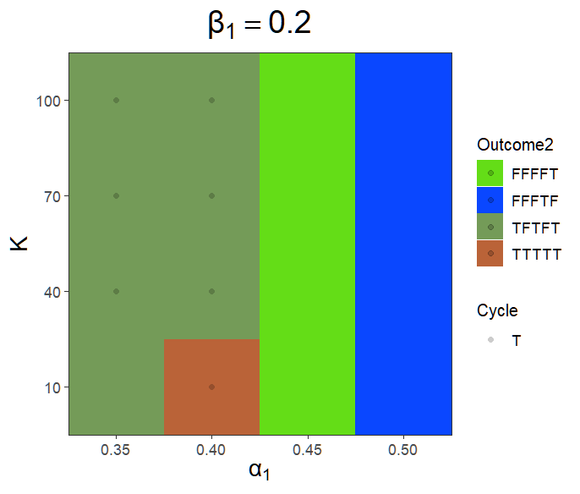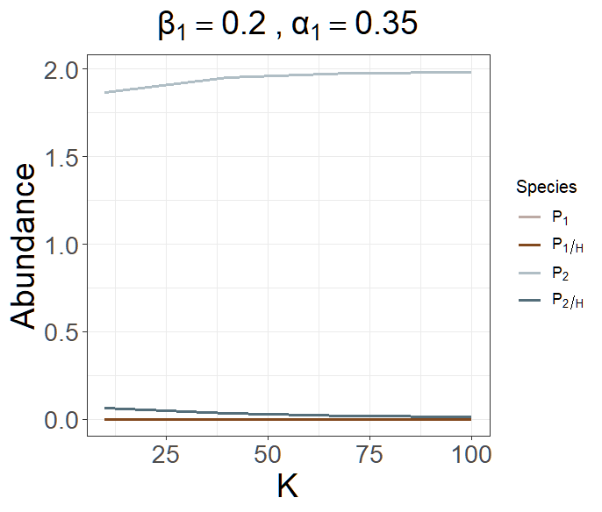
2025/2/16
File name: Pre1Sim3NC Fix β1 = 02 increase K t = 001
Fix β₁ = 0.2, increase K. (time = 100000, 0.01) 這邊cycle 抓太長 (5000000)，所以K =10, α₁ = 0.4 出現cycle，但其實只是抓到還沒跑到equilibrium的波動，可以跑長一點or cycle改抓前2500000 row。
Increasing K will not change the competition outcome (only P₁ wins or P₂ wins). A larger K is expected to increase the system's resources and make H persist, but the simulation outcome didn’t get the expected result.
Population trajectories need to be checked!

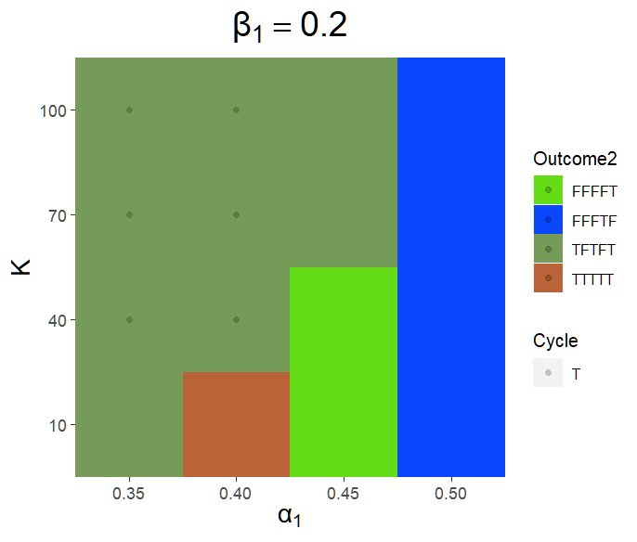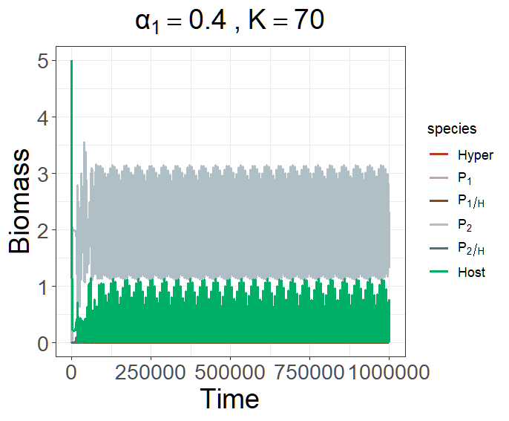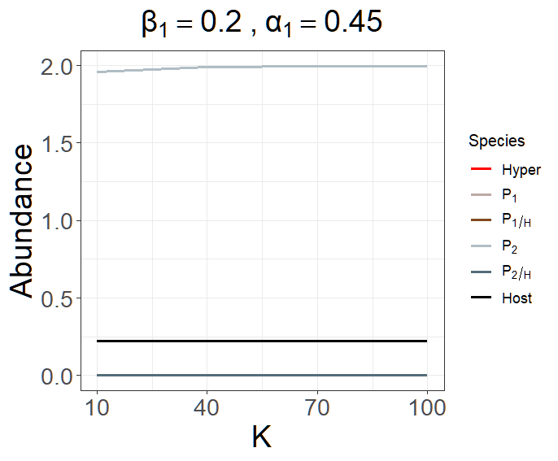
2025/2/18
File name: Pre1Sim3NC Fix β1 = 02 increase K t = 20k, 001
Fix β₁ = 0.2, increase K. (time = 200000, 0.01)
修正了cycle抓太長的問題 (改檢查前2500000列)，並且加長了時間序列。
與先前結果不同，應為時間序列不足，尚未達到equilibrium所致。
When K > 70 and α₁ = 0.45, both P₂ and P_{2/H} will win with the small abundance of P_{2/H}.

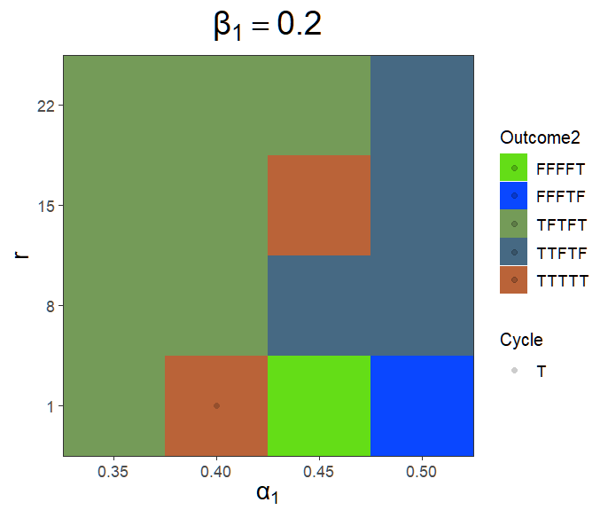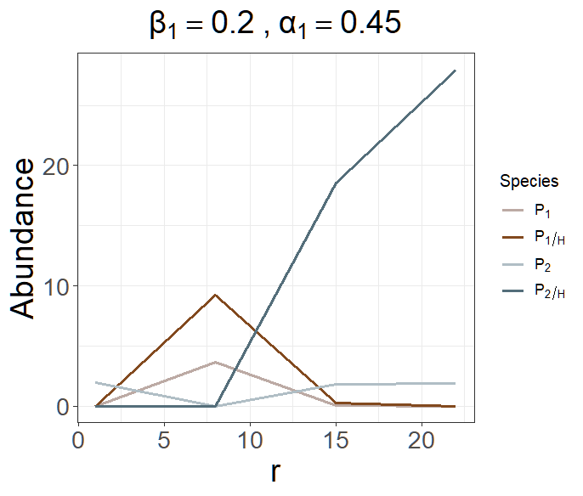

2025/2/16
File name: Pre1Sim3NC Fix β1 = 02 increase r t = 001
Fix β₁ = 0.2, increase K. (time = 100000, 0.01)
Explain WHY
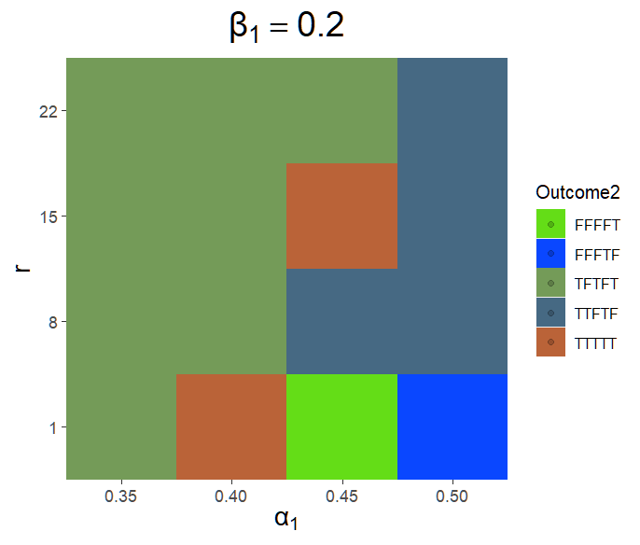
2025/2/18
File name: Pre1Sim3NC Fix β1 = 02 increase r t =20k, 001
Fix β₁ = 0.2, increase K. (time = 200000, 0.01 (above))
同樣修正了cycle抓太長的問題 (改檢查前2500000列)，並且加長了時間序列。
與先前模擬結果相同。

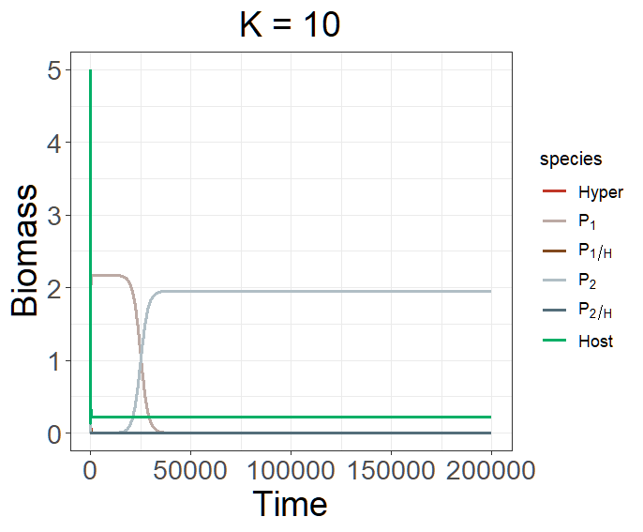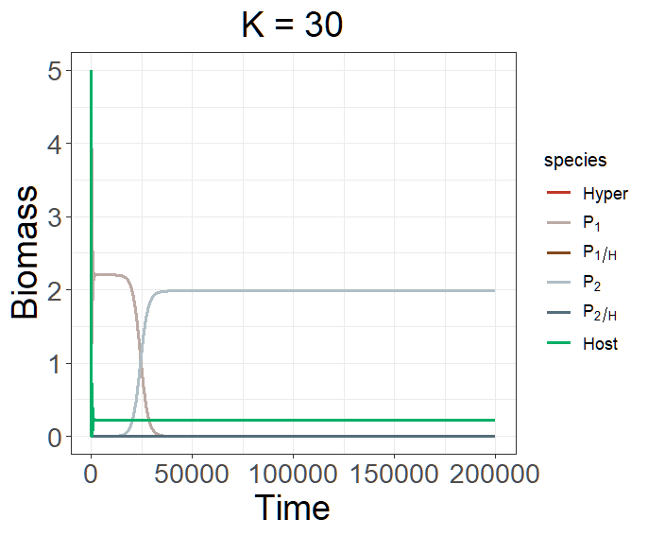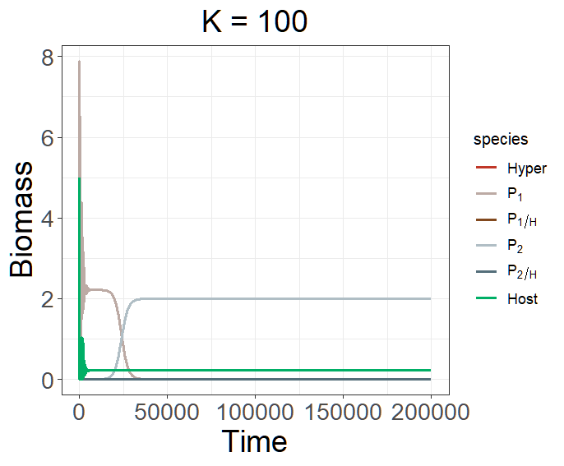(β = 0.45)

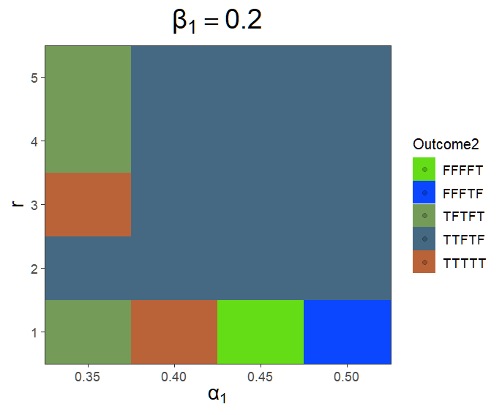
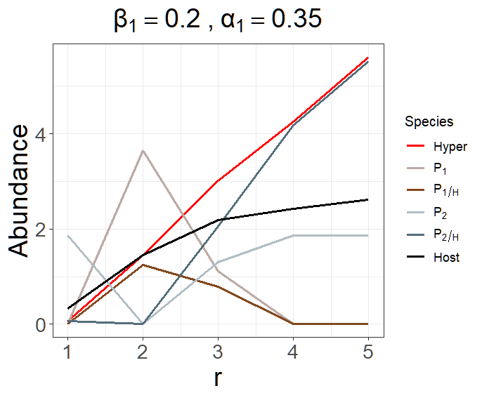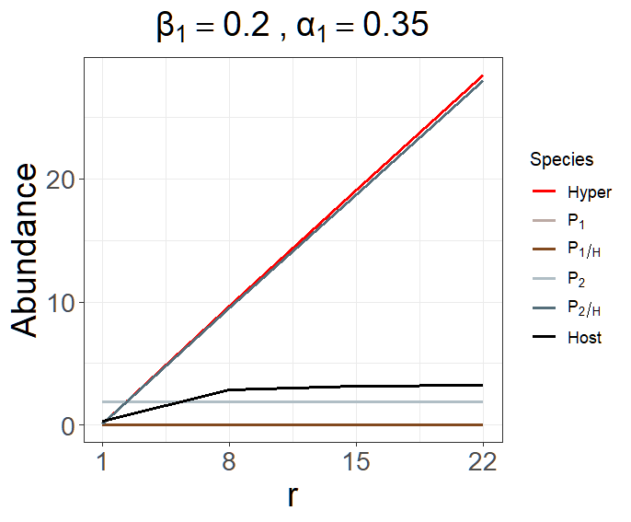
2/25
If one increases r or K, H should have a greater chance to persist. As a result, the system will not leave S, P₁, and P₂ alone and follow the outcome of explotative competition. The situation that P₂ has a greater chance of winning the competition despite higher mortality than P₁ will not happen. Instead, P₁ will have a greater chance to win the competition because of lower β and mortality.
但為什麼繼續增加r反而會回到P₂贏比較多的情況?
The reason why increasing too much r will turn out to be P2 win may be because of the A effect.
Because of the top-down effect.
An increase in r will increase the abundance of S and thus make P₁ and P₂ gain more resources, which are initially beneficial to P₁ because of its low β and high mortality of P₂. However, if one further increases r (= 3), the abundance of P₁ will gradually(?) decrease, and P₂ will start growing again. That might be because more resources are given to both P₁ and P₂. With P₂’s high β and high α, H can accumulate its abundance rapidly. An enormous abundance of H will subsequently compress the living of P₁, even though P₁ has a relatively low transmission rate β, but with a lower consumption rate α, it is hard for P₁ to persist in its population under this situation (r = 4).

Proof:
A similar result is expected if one increases the value of h₂.
#Try fix β₁ = 0.2; α₁ = 0.35
r = 1 to 3, h₂ = 1 to 5
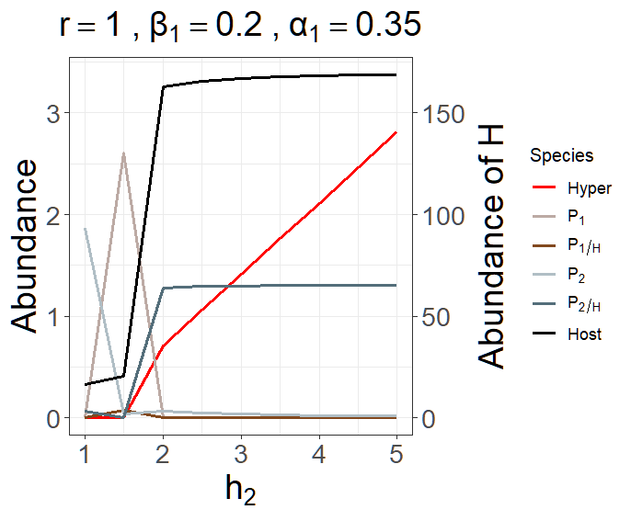
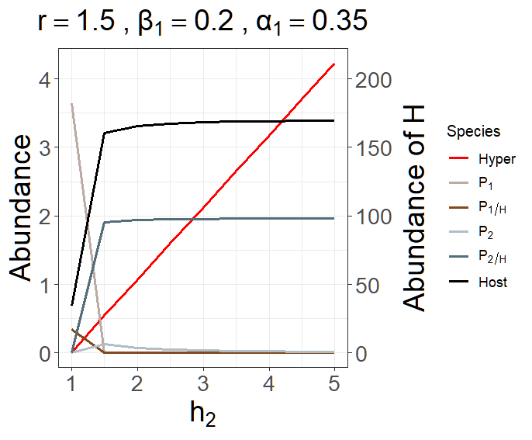
K也會有相同情況嗎?
試著把K放小尺度調整看看。

To prove that the non-persistence of H leads to such competitive outcomes, the K and r are manipulated.

The resource will not decrease to the extent that P₂ can not maintain to support the growth of H.

In contrast, an increase in the value of r can make a big difference.

